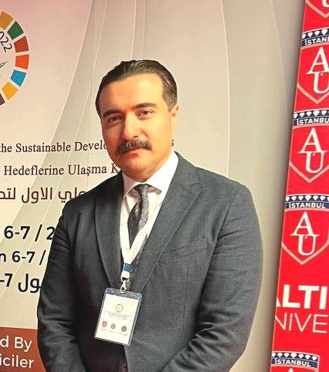

Name: Mohammed Zuhear Al-Mulali
Scientific Degree: Lecturer, Ph.D
E-Mail: mohammed.almulali@coeng.uobaghdad.edu.iq

Profile:
Mohammed Zuhear Abdulameer Al-Mulali received his bachelor’s degree in civil engineering from the Department of Civil Engineering, College of Engineering, University of Babylon in the year 2002. In 2011, He obtained his master’s degree in building technology from the School of Housing, Building & Planning (HBP), Universiti Sains Malaysia (USM). He continued his higher studies to receive a Ph.D from the same school in the year 2016. Worked as lecturer, a head of department, and head of the sustainable development unit in Al-Mustaqbal University. In 2023, he started his career as a lecturer in the Department of Civil Engineering, College of Engineering, University of Baghdad.
His research interests are:
- Foam Concrete
- Concrete Properties
- Pozzolanic Materials
- Sustainable concrete
- Sustainable construction methods and design.

